EXPERIMENT-6

IMPLEMENTATION OF TREE TOPOLOGY USING PACKET
TRACER
Aim: To Implement a tree topology using packet tracer and hence to transmit data
between the devices connected using tree topology.
Software / Apparatus required: Packet Tracer / End devices, Hubs, connectors.
Procedure:
Steps for building topology:
Step 1: Start Packet Tracer
Step 2: Choosing Devices and Connections
Step 3: Building the Topology – Adding Hosts
Single click on the End Devices.
Single click on the Generic host.
Move the cursor into topology area.
Single click in the topology area and it copies the device.
Step 4: Building the Star Topology – Connecting the Hosts to Hubs
Select a Hub, by clicking once on Hub and once on a generic Hub
Add the Hub by moving the plus sign “+”
Step 5: Connect PCs to Hub by first choosing Connections
Click once on the Automatic cable selector
Click once on PC2
Choose Fast Ethernet
Drag the cursor to Hub0
Click once on Hub0
Proceeding in this way create three star topologies
Step 6: Building the Tree Topology – Connecting the Hubs to Active Hub
Connect the hubs of star topologies to active hub to create tree topology.
Step 7: Configuring IP Addresses and Subnet Masks on the Hosts
To start communication between the hosts IP Addresses and Subnet Masks had to be
configured on the devices. Click once on PC0. Choose the Config tab and click on
Fast Ethernet0. Type the IP address in its field. Click on the subnet mask. It will begenerated automatically.
Step 8: Verifying Connectivity in Real time Mode
Be sure you are in Real time mode.
Select the Add Simple PDU tool used to ping devices.
Click once on PC0, then once on PC3.
The PDU Last Status should show as Successful.
Step 9: Verifying Connectivity in Simulation Mode
Be sure you are in Simulation mode.
Deselect all filters (All/None) and select only ICMP.
Select the Add Simple PDU tool used to ping devices
Click once on PC0, then once on PC3.
Continue clicking Capture/Forward button until the ICMP ping is completed.
You should see the ICMP messages move between the hosts, hub and switch. The
PDU last status should show as Successful.
Output:
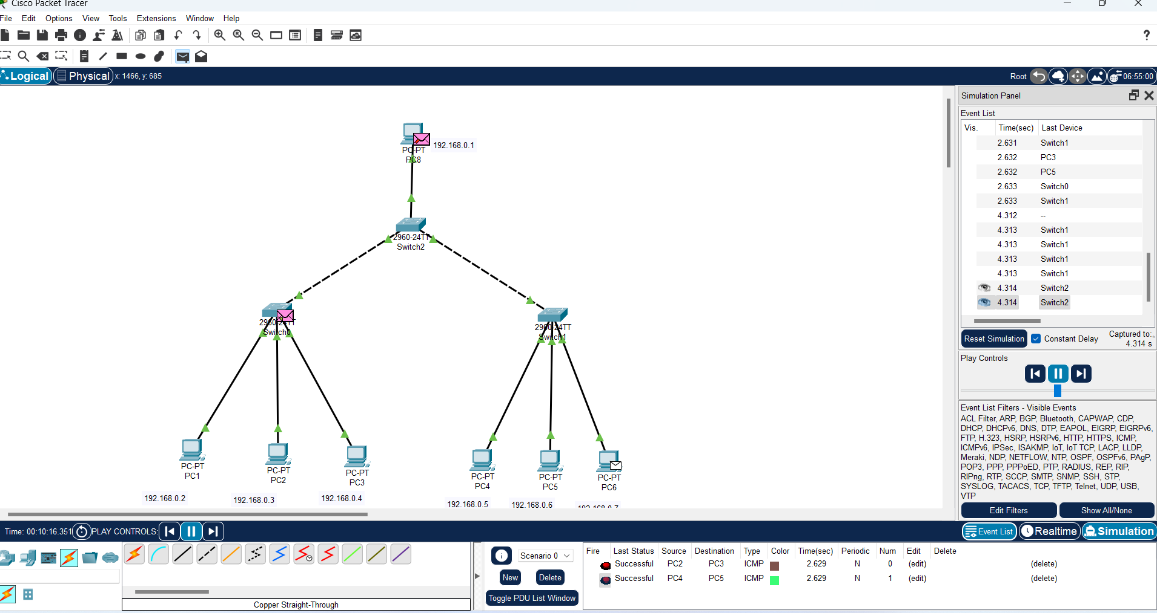

Result: Thus the Tree topology is implemented with Packet Tracer simulation Tool.

